The Rendezvous Problem

The layout of our mission involves the transfer of the Space Tug from the Moon to the Earth, a rendezvous with a target, and then a departure from the Earth to intercept with the Moon once more for future activities. Whilst seemingly simple, I have encountered numerous problems in trying to solve this mission’s trajectory. The problems are as follows, each with their own solutions, some which contradict each other slightly but by writing them out I am hoping to find an overall solution.

There are two important parameters to keep in mind throughout all of these problems: deltaV, which denotes how much propellant will be used by the Space Tug throughout the mission; and time, we don’t just have to leave the Moon but return to it also.

# Changing Inclination

Given that our targets are in GEO, it is most likely that they will be orbiting at an inclination of zero degrees around the Earth’s equator. This poses a problem as the Space Tug will almost certainly not be at this same inclination at the beginning of its mission. In fact, there are two inclination differences between the Space Tug’s initial trajectory and its trajectory at the Earth: The Space Tug’s inclination to the Moon (currently given as 78.4 degrees) and the Moon’s inclination to the Earth (approximately 28 degrees).

An inclination change manoeuvre is highly dependent on the velocity of the spacecraft. Assuming the spacecraft maintains the same velocity regardless of its inclination change, the equation for such a manoeuvre is:

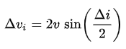

Thus, the faster the spacecraft is moving the more deltaV is required. In the preliminary trajectory, the Space Tug is intended to perform an S-shape trajectory from the Moon, through the L1 point, and down to the Earth. As such, there are three nodes where the inclination can be successfully changed. The first is during the initial orbit around the Moon (v = 1,600 m/s), the second is during the final orbit around the Earth (v = 3,074 m/s), and the final is at the node where the Space Tug changes direction at L1 (v = 1,000 m/s). As can be seen, the latter is the best option with the lowest velocity, but it isn’t the only thing that needs to be considered.

As mentioned, the Moon is also at an inclination to the Earth’s equatorial plane. Thereby, changing to an inclination of zero at L1 isn’t always possible as L1 is nearly always not on the equatorial plane either. Thus, a double solution is needed.

First, the Space Tug is to attempt to manoeuvre into an inclination change of zero at L1, here it can remove the inclination change caused by the Space Tug’s initial inclination around the Moon but can leave up to 28 degrees of inclination due to the Moon’s orbit. Secondly, the Space Tug performs another inclination change manoeuvre at GEO to sort out the rest of the problem, it is a much higher usage but in many cases GEO is the first point where the Space Tug crosses the equatorial plane and the actual only point where this manoeuvre can take place.

With these two nodes found, numerous tests were run to find the optimal time in the Moon’s orbit (29-day period) to perform the entire trajectory. The results of which are shown below:

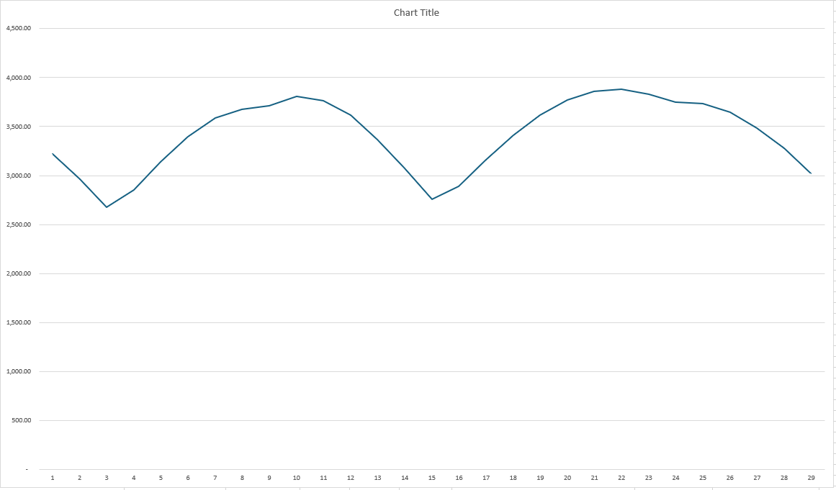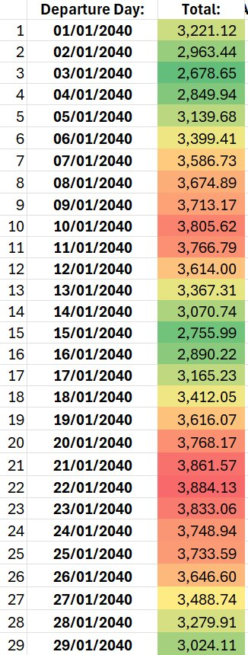

By timing the trajectory, the deltaV can be reduced by up to 1,200 m/s. This minimum value corresponds to the Space Tug performing the inclination change at L1 when the Moon crosses the equatorial plane, greatly reducing the inclination change needed at GEO.

Thus, for best case scenario there are two options for the deltaV, either cross the L1 during the ascension of the Moon, or during the descension of the Moon.

# Flying back out to the Moon

For the return to the Moon, a similar solution can be imposed. Keeping the Space Tug in a zero inclination GEO orbit and launching to Lunar orbit at the perfect time, the apoapsis of the Space Tugs orbit will coincide with when the Moon crosses the equatorial plane. Then only slight manoeuvres will be needed to get back to LLO.

This does however put a timing boundary on the launch from GEO. This manoeuvre can only be done about once every two weeks otherwise intense inclination changes will be needed. If the Space Tug misses the departure date, the most deltaV efficient method would be to wait in GEO for two weeks until the next departure date.

# Rendezvousing with the Target

Once the Space Tug arrives at GEO, it will then need to rendezvous with the Target. There are two methods of doing this through either inner or outer rendezvous where inner describes an elliptical orbit with a semimajor axis smaller than GEO and an outer is an elliptical orbit with a semimajor axis larger than GEO. Both orbits have their upsides and downsides that directly impact our main two parameters. Inner rendezvous take much less time but require much more deltaV, whereas outer rendezvous take at least one whole orbit (day) but require much less deltaV.

There is a caveat however, as the Space Tug will be approaching GEO from a high eccentricity elliptical orbit, it’s velocity will begin higher than any outer rendezvous could ever be. Thus, it is now much more deltaV efficient to perform an outer rendezvous than an inner rendezvous. This is shown in the figure below:

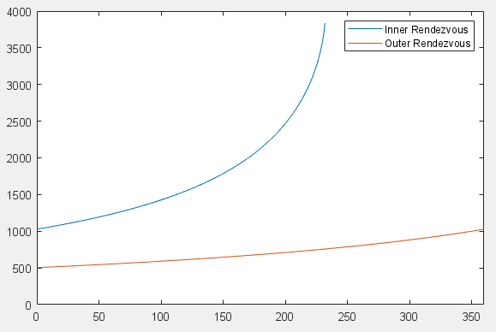

As can be seen, the inner rendezvous only works up to an angle of approximately 230 degrees. After this point the Space Tug would not be able to slow down enough to orbit in an ellipse and instead the Space Tug would crash into the earth. Thus, if the Target is more than 230 degrees forward, the Space Tug would have to do an outer rendezvous to reach it.

With the most efficient deltaV option clearly being an outer rendezvous, the attention now turns to how long such a manoeuvre would take. Fortunately, once the new semimajor axis is known, the periods can easily be calculated:

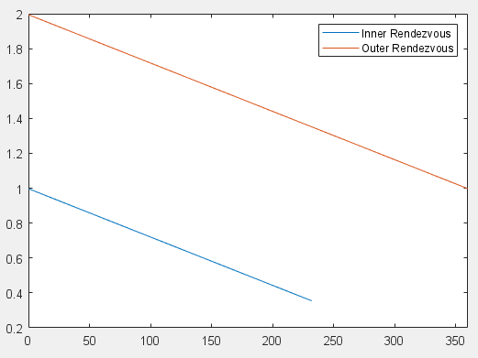

Current estimates show the Space Tug only having approximately five days to rendezvous with the target before having to depart GEO. As such, it can’t really be afforded to spend two days rendezvousing with the target, assuming it takes a day to capture the target and a further two days to rendezvous to the departure node, there is practically no margin of error. A different solution is needed.

Fortunately, the solution comes much earlier in the overall trajectory, we can launch from the Moon at any time. Initial calculations show that varying the departure time by a few hours causes an almost exact change in the time of arrival at Earth, the only difference between the trajectories being the allowed inclination change at L1 and the resulting change in deltaV. Current estimates show the increase in deltaV by varying the launch date by +- 12 hours is around 150 m/s, far less than the >500 m/s currently needed for the rendezvous. The only deltaV now needed is for circularisation as well as a slight amount in case of a miscalculation, but that will presumably be covered by the fuel margin.

The Space Tug will now arrive at most 12 hours later, rendezvous with the target almost immediately at GEO, and then need to rendezvous to the Departure Node for which it has at least three and a half days to carry out any manoeuvres.

The deltaV for the manoeuvre can be accurately predicted by the following equation:

 (m/s)

Where td is the departure time (in hours) either before or after the optimum departure time. This deltaV is for the entire manoeuvre from LLO to a circular GEO. Changing the departure time however changes the arrival time at GEO, this is of course wanted in order to properly rendezvous with the Target. As such, the change in arrival time is related to the change in departure time by the following relation:

 (hours)

Changing the departure time has a larger effect on the arrival time, this is good as it will result in less of a change of deltaV but still full 360-degree coverage of possible Target placements. The maximum magnitude of the change in arrival time is 11 hours 58 minutes and 3 seconds, thus the maximum magnitude of the change in departure time is 10 hours 44 minutes and 5 seconds, this thus results in a maximum deltaV for the trajectory from LLO to GEO of 2,811 m/s.

The worst-case scenario as calculated above is for when the Target is 180 degrees away from the entry node for the optimal trajectory, this results in the aforementioned time change of nearly 12 hours. For a general angular difference between the optimal entry node and the target, the equation is as follows:

 (hours)

Where the angle change is between -180 and 180 degrees and the time change is measured in hours. From this, a simplified equation for the deltaV of the trajectory only dependant on the angle change from the optimal entry node can be derived:

 (hours)

 (m/s)

DeltaV0 here is the deltaV required to do the optimum trajectory, in my initial tests it was the 2672.38 from earlier. Preliminary orbital analysis of the optimal trajectory and the Target placement can give that angle change and thus the deltaV can be calculated for any target placement.

# Rendezvousing with the Departure Node

The departure node is a non-real reference point in GEO where the Space Tug will need to be at the time of departure in order to successfully manoeuvre back to the Moon. The node is almost exactly 180 degrees away from the Entry node in a physical sense, however due to the time of stay in GEO, the actual angular difference between the Space Tug’s entry (and the Target’s placement) and the Departure Node is:

 (degrees)

In degrees, where deltatGEO is the time between entry and exit for the Space Tug. This brings back the rendezvous problem from the previous issue. Fortunately, in this case the Space Tug has at minimum 5 days and 5 hours to do any manoeuvre that will at most take 2 sidereal days and thus the best option will be the one with the lowest deltaV. This is an outer transfer, the equations of which are as such for a GEO rendezvous:









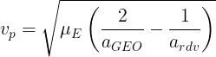

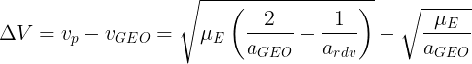

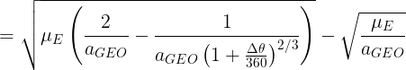

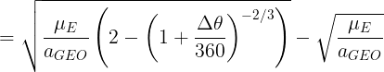

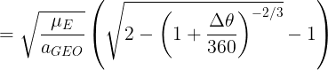

The option is also there, should there be enough time, to half the angular change and double the time taken for the manoeuvre. This will then result in a reduction in the deltaV for the rendezvous.